**Model 1 (classic definition):**

**Model 1** → No model layer.  
Flow: **UI → JSP/Servlet (Controller + View + Business + DB logic) → DB → Response**

* DB access and business logic are inside the JSP/Servlet itself.

**🔹 Model 1 Architecture (Elaborated)**

**1. What is Model 1?**

* In **Model 1**, a web application is developed using **only one type of main component**:
  + Either **Servlets only**, or
  + **JSPs only**.
* That single component is responsible for **everything**:
  + Accepting requests from the user.
  + Processing the request (business logic).
  + Talking to the database.
  + Generating the response (usually HTML).

So, one file/class is doing **too many jobs**.

**2. Example (Servlet-based Model 1)**

* A user submits a form → Request goes to a Servlet.
* The Servlet:
  1. Reads the request parameters.
  2. Validates data.
  3. Connects to the database using JDBC.
  4. Runs SQL queries.
  5. Prepares HTML output (using out.println() statements).
  6. Sends that HTML as a response back to the browser.

👉 That one Servlet is mixing **controller logic**, **business logic**, **database logic**, and **view logic** all together.

**3. Example (JSP-based Model 1)**

* A user submits a form → Request goes to a JSP.
* The JSP:
  1. Reads the request using JSP scriptlets (<% %>).
  2. Contains Java code inside the JSP file to call the database.
  3. Implements business logic (calculations, conditions, loops).
  4. Displays the result in HTML.

👉 That one JSP is acting as **controller**, **business layer**, and **view** at the same time.

**4. Problems in Model 1**

* **Code Mixing:**
  + Business code, presentation code, and database code all live in one file.
  + Example: A JSP might have 30 lines of HTML, 40 lines of Java code, and 20 lines of SQL. Messy to read.
* **Hard to Maintain:**
  + If business rules change → you must edit JSP/Servlet directly.
  + If database schema changes → again, edit JSP/Servlet directly.
  + If UI changes → again, edit the same file.
  + A small change can break other parts accidentally.
* **Poor Reusability:**
  + The logic is tied to that JSP/Servlet.
  + If another part of the app needs the same logic, you’ll probably **copy-paste code** instead of reusing it.
* **Testing Difficulty:**
  + To test the business logic, you need to run the JSP/Servlet inside a web server (Tomcat).
  + You can’t just test the logic independently because it’s mixed with HTML and HTTP request/response.
* **Team Collaboration Issues:**
  + Frontend/UI developers (HTML, CSS, JS experts) cannot work easily, because JSPs/Servlets contain both **Java** and **HTML** mixed together.
  + Backend developers cannot isolate and test their logic independently.
* **Scalability Issue:**
  + As the project grows, files become longer and unmanageable.
  + Example: A 1,000-line JSP that has HTML + Java + SQL all mixed → nightmare to debug and maintain.

**5. When is Model 1 Acceptable?**

* For **very small applications**:
  + Personal projects.
  + Simple student projects.
  + Prototypes or demos where speed is more important than maintainability.

Example:

* A small **Login app** where a JSP checks username/password from a database and displays “Login Success/Failure”.
* A **Feedback form** storing entries into DB and showing “Thank you” page.

👉 These apps are small enough that mixing code is not a big problem.

**6. Why Model 1 Fails for Medium/Large Apps?**

* As soon as your app grows (multiple pages, many business rules, multiple developers working together), Model 1 becomes **unmanageable**.
* Debugging and enhancing the system becomes very costly.
* The **lack of separation of concerns** is the biggest drawback.

✅ **In simple words:**  
Model 1 = “All-in-one approach” → one file does everything.  
Good for **small toys**, terrible for **big houses**.

**✅ MVC1 Architecture (Elaborated)**

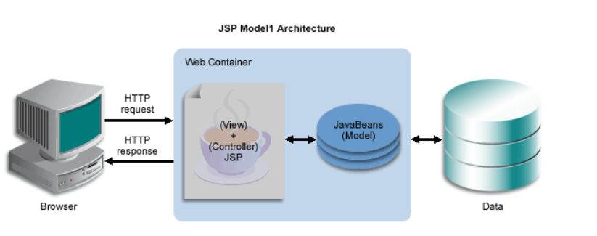

**MVC1:**

* Flow: **UI → JSP/Servlet (Controller + View) → Model (JavaBeans/Classes with business + DB) → DB → Response**
* Model layer exists (separated).
* JSP/Servlet still mixes Controller + View, but at least business/DB logic is moved into Java classes.

**1. What is MVC1?**

* MVC1 was an **improvement over Model 1**.
* The idea was to **separate Model (business logic, database logic)** from the web component.
* But the separation between **Controller** and **View** was still not clean.

👉 In MVC1:

* Either a **JSP** or a **Servlet** takes the double role of **Controller + View**.
* The **Model** (JavaBeans, helper classes, DAOs, POJOs) is separate and reusable.

**2. Example (JSP-based MVC1)**

* A user submits a form → Request goes to a JSP page.
* That JSP:
  1. Reads request parameters.
  2. Decides what action to take (Controller responsibility).
  3. Calls JavaBeans or helper classes to execute business/database logic (Model).
  4. Displays the result as HTML (View).

👉 The JSP is doing **both Controller and View** tasks.

**3. Example (Servlet-based MVC1)**

* A user submits a form → Request goes to a Servlet.
* That Servlet:
  1. Reads request parameters.
  2. Decides what to do next (Controller responsibility).
  3. Calls the Model (Java classes/Beans) for business/database logic.
  4. Directly writes the HTML response using out.println() (View).

👉 The Servlet is doing **both Controller and View** tasks.

**4. Improvements over Model 1**

* In **Model 1**, database and business logic were mixed inside JSP/Servlet.
* In **MVC1**, these are moved to **separate Java classes (Model layer)**.
* Benefits:
  + Business logic can be reused across multiple components.
  + Model classes are easier to test (unit testing possible).
  + Code is slightly more organized.

So, MVC1 solved **some problems** of Model 1 but not all.

**5. Problems in MVC1**

* **Controller + View are tightly coupled:**
  + One component is handling request flow (Controller role) **and** generating HTML (View role).
  + This means you cannot fully separate presentation from navigation logic.
* **Not fully clean separation of concerns:**
  + If JSP is the main component: Java code (for controlling flow) still lives inside a JSP → UI developers struggle.
  + If Servlet is the main component: Too much HTML inside out.println() → backend developers struggle.
* **Limited scalability:**
  + For small-to-medium projects, MVC1 can work.
  + But as projects grow, mixing Controller and View responsibilities makes it harder to maintain.
* **Collaboration issues (though better than Model 1):**
  + Since Controller and View are mixed, frontend and backend teams cannot work independently.
  + Still requires coordination because one file handles multiple responsibilities.

**6. When is MVC1 Acceptable?**

* For **medium-sized projects** where some organization is needed but the project is not very large.
* Example:
  + A small **shopping cart system**.
  + A **student management system**.
  + Applications where the number of pages and features are limited, but you want to keep Models separate.

👉 In short: **better than Model 1**, but not the best choice for large-scale industry projects.

**7. Why Industry Moved Away from MVC1**

* As soon as applications grew more complex, MVC1 became hard to maintain.
* The tight coupling between Controller and View made it difficult to:
  + Add new UI technologies.
  + Reuse Controllers across multiple Views.
  + Scale to large teams and projects.

That’s why **MVC2** was introduced → with **strict separation**:

* JSP = only View.
* Servlet = only Controller.
* Java classes = Model.

✅ **In simple words:**

* **Model 1** = one file does everything (messy).
* **MVC1** = improved: Model is separate, but Controller + View are still mixed.
* **MVC2** = clean separation: Controller, View, and Model are all separate.

**✅ MVC2 Architecture (Industry Standard)**

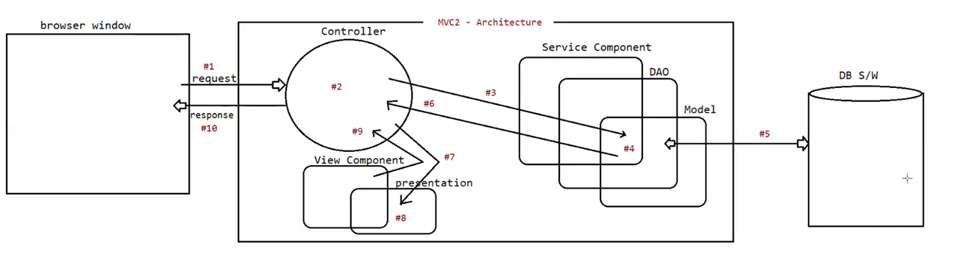

# ****MVC2 Architecture – Complete Flow****

### Step-by-Step Process

1. **#1 Browser Request**
   * The user performs an action (e.g., clicks a button, submits a form).
   * The browser sends an **HTTP request**.
2. **#2 Controller**
   * The **Controller (Servlet)** receives the request.
   * It decides what needs to be done (navigation logic).
3. **#3 Controller → Service Component**
   * The Controller forwards the request to the **Service component**.
   * The Service contains business logic.
4. **#4 Service → DAO**
   * The Service calls the **DAO (Data Access Object)**.
   * DAO contains database interaction code.
5. **#5 DAO → Database (DB S/W)**
   * DAO communicates with the **database software**.
   * Fetches or updates data in the DB.
6. **#6 Returning Data (DAO → Service → Controller)**
   * The data retrieved/processed from the DB moves back:  
     **DAO → Service → Controller**.
7. **#7 Controller → View Component**
   * Now, the Controller forwards the processed data to the **View Component (JSP)**.
8. **#8 Inside the View Component (Presentation Block)**
   * Inside the View, the **Presentation block** is present.
   * Here, the presentation logic (formatting, displaying data, UI styling) is applied.
   * Example: Data from DB is shown as a table, styled, or combined with HTML/CSS.
9. **#9 View → Controller**
   * After presentation logic is applied, the formatted output is ready.
   * The **View returns this formatted content back to the Controller**.
10. **#10 Controller → Browser Response**
    * Finally, the Controller sends the **response back to the Browser**.
    * The user sees the formatted output on the screen.

**1. What is MVC2?**

* MVC2 is the **refined and industry-accepted architecture** for building Java web applications.
* The main principle is **strict separation of responsibilities** into three independent layers:
  + **Model** → Represents business logic & data (pure Java classes).
  + **View** → Represents the user interface (JSP/HTML/CSS/JS).
  + **Controller** → Handles user requests, decides flow, and coordinates Model and View.

👉 Unlike MVC1, no single component does multiple jobs. Each part has **one job only**.

**2. Flow of MVC2 (Step by Step Example)**

Let’s take a **Student Registration** example:

1. **User Action (Browser)** → The user fills out a form (studentForm.jsp) and clicks submit.
2. **Controller (Servlet / Framework Controller)**
   * The request goes to a **Controller** (e.g., StudentControllerServlet or DispatcherServlet in Spring MVC).
   * The Controller:
     + Reads form data.
     + Decides which Model (Java class) should handle it.
     + Calls the Model class.
3. **Model (Business Layer)**
   * A Java class (e.g., StudentService + StudentDAO) does the real work:
     + Validates data.
     + Talks to the database (Insert student record).
     + Returns results (success/failure).
4. **Controller (again)**
   * Based on the result from the Model, the Controller decides which View should be shown.
   * Example: If success → forward to success.jsp, else → error.jsp.
5. **View (JSP)**
   * JSP displays the data nicely in HTML/CSS format.
   * **Important:** JSP here is *only for presentation*. No business logic inside JSP.

**3. Clear Responsibilities**

* **Model** → Pure Java classes, no knowledge of HTTP/Servlet/JSP.
* **Controller** → A central decision-maker (Servlet / DispatcherServlet).
* **View** → JSP/HTML/CSS/JS for presentation only.

This makes MVC2 applications **organized and modular**.

**4. Benefits of MVC2**

* **Clear Separation of Concerns**
  + Controller only routes requests.
  + View only handles presentation.
  + Model only contains logic.
  + Each layer can be changed independently without breaking others.
* **Maintainability**
  + Business logic changes? → Change Model only.
  + UI changes? → Change JSP only.
  + Routing changes? → Change Controller only.
  + This reduces bugs and makes large projects easier to handle.
* **Reusability**
  + Model classes are pure Java (POJOs), reusable across other applications or services.
  + Same Model can be used with different Views (e.g., JSP, Angular frontend, REST API).
* **Testability**
  + Model classes can be tested independently (unit tests).

### Line: ****“Controller logic can be tested with mocks.”****

#### 1. **What it means?**

* In MVC, the **Controller** is responsible for taking input, calling services/DAOs, and passing data to the View.
* When we test the Controller, we don’t always want to connect to the real **Service/DAO/Database** because:
  + It makes testing slow.
  + It may change real data.
  + It requires DB setup.

So instead, we use **mocks** → **fake objects** that behave like real Service/DAO objects but don’t actually connect to the DB.

#### 2. **Mocks in simple words**

* A **mock** is a dummy/fake object that returns **predefined responses** when called.
* Example: Instead of calling a real database to fetch students, the mock service will just return a **fake student list**.

#### 3. **How it helps in testing Controller?**

* You can test **only the Controller logic** (input handling, request mapping, navigation, response building)
* Without worrying about whether DB, DAO, or Service are working.

#### 4. **Example** (in very simple Java terms):

// Controller method

public String getStudentPage(Model model) {

List<Student> students = studentService.getAllStudents();

model.addAttribute("students", students);

return "studentView";

}

👉 Problem: If we call this method, it will call the **real studentService**, which may hit the DB.

👉 Solution: Use a **mock studentService**:

@Test

public void testGetStudentPage() {

// Mocking service

StudentService mockService = Mockito.mock(StudentService.class);

Mockito.when(mockService.getAllStudents())

.thenReturn(Arrays.asList(new Student("Pavan"), new Student("Ravi")));

// Inject mock into controller

StudentController controller = new StudentController(mockService);

Model model = new ExtendedModelMap();

String viewName = controller.getStudentPage(model);

assertEquals("studentView", viewName);

assertEquals(2, ((List)model.getAttribute("students")).size());

}

Here:

* We **mocked studentService** (instead of real DB call).
* Controller logic (adding students to model + returning view name) is tested **independently**.
  + This was impossible in Model 1 and hard in MVC1.
* **Scalability**
  + Works very well for large applications with many developers.
  + Teams can work in parallel:
    - Frontend team → focuses only on JSP/HTML/JS (View).
    - Backend team → works on Model (business rules, DB).
    - Integration team → works on Controller.

**5. Industry Adoption**

* **Every major Java web framework is based on MVC2:**
  + **Struts** → Classic MVC2 framework.
  + **JSF (JavaServer Faces)** → Component-based MVC2.
  + **Spring MVC / Spring Boot MVC** → Most popular modern MVC2 frameworks.

👉 When Java developers/companies say **“MVC Architecture”**, they almost always mean **MVC2**.

**6. When to Use MVC2**

* For **medium to large applications** where maintainability, scalability, and team collaboration matter.
* Examples:
  + E-commerce platforms (Amazon-like apps).
  + Banking applications.
  + Enterprise portals (HR, ERP, CRM).
  + Social networking or collaboration tools.

**7. Why MVC2 Replaced MVC1**

* In MVC1, Controller and View were still mixed → messy.
* In MVC2, they are completely separate → clean and modular.
* This makes MVC2 the **industry standard** for web apps, and the foundation of all modern frameworks.

✅ **In simple words:**

* **Model 1** = “One-man band” (one file does everything).
* **MVC1** = “Two-man team but one person still multitasking” (Model separate, but Controller + View still mixed).
* **MVC2** = “Well-organized team” (Model, View, Controller each have clear roles).

## 🔑 Difference Between MVC1 and MVC2

### 1. Controller

* **MVC1:**
  + There is no separate Controller.
  + A JSP or Servlet itself acts like the Controller (it handles the request flow).
* **MVC2:**
  + There is a clear, separate Controller (a Servlet or framework controller).
  + Its only job is to handle requests and decide where to go next.

### 2. View

* **MVC1:**
  + The same JSP/Servlet that acts as Controller also handles the View (displays data).
  + So, Controller and View are mixed together.
* **MVC2:**
  + View is completely separate.
  + JSP is used only for showing data to the user. No request-handling or decision-making here.

### 3. Model

* **MVC1:**
  + Model (business logic and database logic) is separate, but it is still connected tightly with Controller + View.
* **MVC2:**
  + Model is fully separate.
  + It does not depend on Controller or View. It’s just plain Java classes (POJOs, Services, DAOs).

### 4. Coupling (Connection Between Parts)

* **MVC1:**
  + Controller and View are **tightly coupled** (mixed together in the same component).
* **MVC2:**
  + Controller, View, and Model are **loosely coupled** (each part has its own role).

### 5. Use Case

* **MVC1:**
  + Works fine for **small to medium applications**.
  + But becomes hard to manage as projects grow bigger.
* **MVC2:**
  + Best for **medium to large applications**.
  + Industry standard because it is clean, scalable, and maintainable.

👉 **In short:**

* **MVC1:** Controller + View in one place, Model separate.
* **MVC2:** Controller, View, and Model all separate → much cleaner.